H.T No
Regulations:
A17

Sreenidhi Institute of Science and Technology
(An Autonomous Institution)
Code No: 6A201 Date: 26-Nov-2020 (FN)

B.Tech I-Year II-Semester External Examination, Nov/Dec - 2020 (Supplementary)
CIRCUITS AND NETWORKS – I (EEE)

Time: 2 Hours Max.Marks:75

Note: a) No additional answer sheets will be provided.
b) All sub-parts of a question must be answered at one place only, otherwise it will not be valued.
c) Missing data can be assumed suitably.

ANSWER ANY 5 OUT OF 8 QUESTIONS. EACH QUESTION CARRIES 15 MARKS.

1. | a) | What are the various types of sources? Briefly discuss. | [8M]
 | b) | Using nodal analysis find the voltage V in the circuit shown in the below figure which makes the current in the 10Ω resistor as zero.  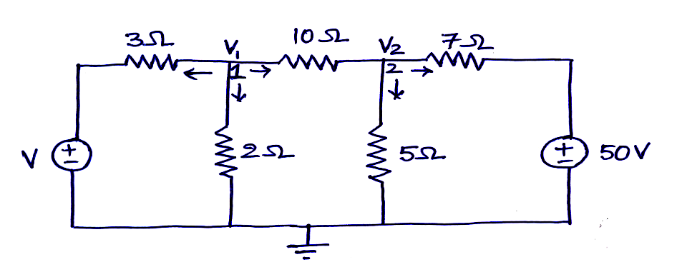 | [7M]
2. | a) | Explain the procedure for obtaining the incidence matrix of a given network. | [8M]
 | b) | Obtain the tieset matrix for the network shown in below figure.  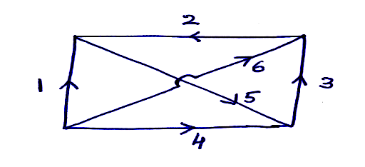 | [7M]
3. | a) | Explain about the analogy between electric and magnetic circuits. | [8M]
 | b) | Find the equivalent inductance of two coupled coils connected in series. | [7M]
4. | a) | Explain about the response of series RL circuit to sinusoidal excitation. | [8M]
 | b) | A resistor of 100Ω is connected in series with a 50μF capacitor. Find the effective voltage applied to the circuit at a frequency of 50Hz. The effective voltage across the resistor is 170V. Also determine voltage across the capacitor and phase. | [7M]
5. | a) | Derive the expression for resonance frequency in terms of half power frequencies of RLC series circuit. | [8M]
 | b) | A series RLC circuit has a quality factor of 5 at 50 rad/sec. The current flowing through the circuit at resonance is 10A and the supply voltage is 100V. The total impedance of the circuit is 20Ω. Find the circuit constants. | [7M]
6. | a) | State and explain Millman’s theorem. | [8M]
 | b) | Verify the reciprocity theorem for the circuit shown in below figure.  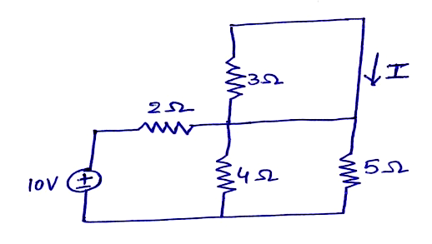 | [7M]
7. | a) | Find the average and effective values of the saw tooth waveform shown in the below figure.  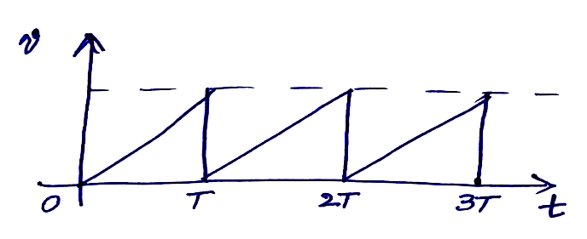 | [8M]
 | b) | Three resistances are connected in parallel having the ratio of 1:2:3. The total power consumed is 100W when 10V is applied to the combinations. Find the values of the resistances. | [7M]
8. | a) | State and explain Norton’s theorem. | [8M]
 | b) | Obtain the expressions for bandwidth and quality factor for a parallel RLC circuit. | [7M]

-- 00 -- 00 –

